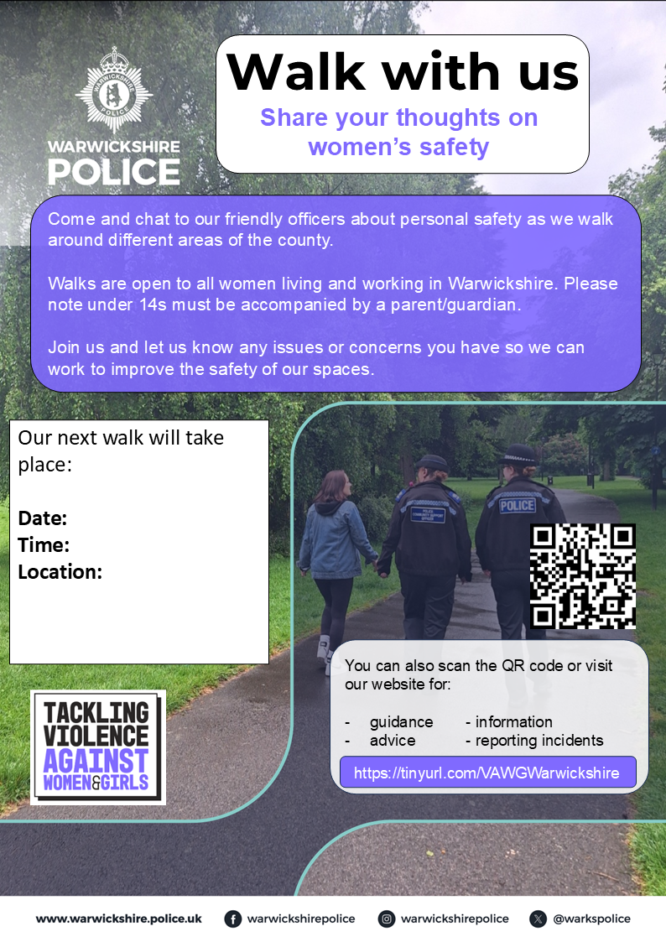
Our Next Walk will take place
Date: Thursday 8th October 2026
Time: 6.30pm
Location: Morrisons Daily Spinney Hill CV34 5SR
The walk will be approx. 2 miles, suitable for all and will end back at the start.

