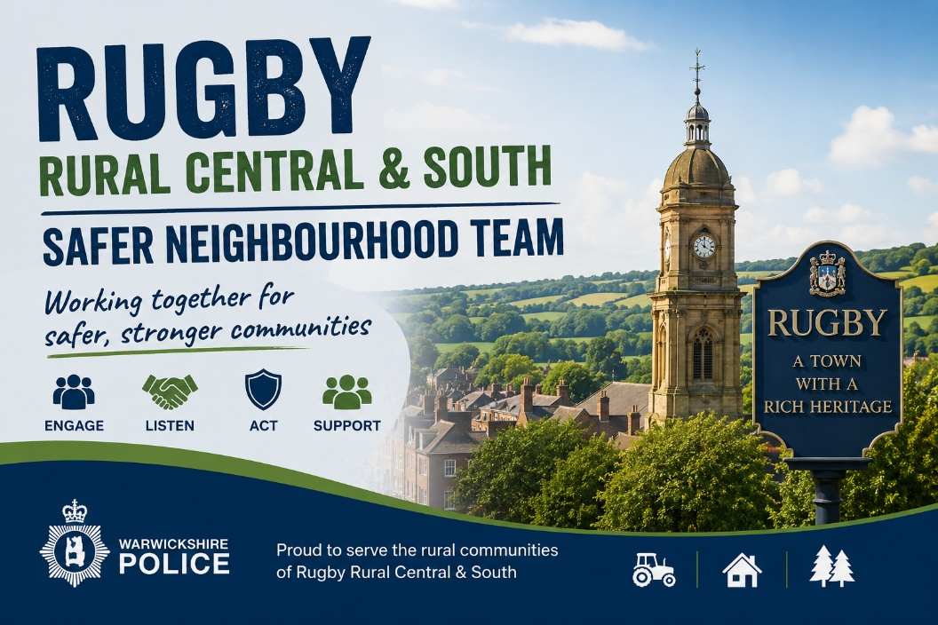

Inspector 1780 Stephanie Brown
Sergeant 1303 Ricky Franklin
RUGBY RURAL CENTRAL TEAM
PC 2223 Seb Payne
PCSO 6252 Samantha Goode
PCSO 8826 Callum Moriarty
RUGBY RURAL SOUTH TEAM
PC 2220 Seb Payne
PCSO 6137 David Banks
PCSO 8909 Paula Parkes

Rugby Rural Central and South Police SNTs. May Report.

Based at Rugby Police Station, The Safer Neighbourhood team’s primary roles are around crime prevention, problem solving both long standing or emerging issues of community concern and community engagement. We are supported at Rugby by colleagues from Patrol teams whose role is to respond to incidents and investigate crimes that occur in the area 24/7. The SNT is supervised by Inspector Stephanie Brown who leads on Neighbourhood Policing for Rugby District and Sgt Ricky Franklin who also oversees neighbourhood Policing in the rural area of Rugby. The Rugby Rural SNT currently consists of 3 Police officers and 6 Police Community Support Officers, and our contact details are shown above.

Hello all.
This is our latest combined monthly report. For operational and privacy reasons not all the incidents that occur on the area are listed in this report, although they are recorded on police systems.
Please remember to report any anti-social behaviour, suspicious activity or crimes to us as soon as possible - this can be done via the 101 and 999 telephone numbers or if not an emergency via our online reporting forms that can be found on our website. If you have any information or cctv footage that may relate to the incidents listed, please contact us.

INCIDENT AND CRIME NUMBERS
Central Region
Total Incidents - 239
Violence Incidents - 9
ASB Incidents - 14
Vehicle Incidents - 3
Other Crimes - 0

South Region
Total Incidents - 118
Violence Incidents - 4
ASB Incidents - 17
Vehicle Incidents - 0
Other Crimes - 0

Incidents of a public interest from the last month: -
CAWSTON - Fly tipping seen by passing motorist in local area. Officers attended no trace of suspects or potential fly tip
LONG LAWFORD - Tee Tong Road – Lots of reports of youth riding scooters at speed without helmets in an anti-social manner
BINLEY WOODS - On-going issues with off-road bikes in the area generally at weekends. 3x S59 warnings issued and warning letters to vehicles linked with the use of off-road bikes.
RYTON ON DUNSMORE - Freeboard Lane and surrounding areas – Regular fly-tipping on this lane including the remains of cannabis grows (plants and equipment) and car parts (VRM plates, tyres, wheels).
​CEVA Logistics - Motorcycles parked up belonging to the staff working at this industrial unit are being targeted for theft of bikes.
CHURCH LAWFORD - Nothing of interest
BRANDON - Nothing of interest
WOLSTON - Parking across the crossing on STRETTON WAY. Officers to do patrols at busy times to identity suspect/vehicle.
DUNCHURCH - 2 x Burglaries at petrol stations. These are being targeted. Any information contact police regarding this.
MARTON – Reports of antisocial driving of a quad around the village
GRANDBOROUGH – Reports of vehicle crime and thefts from vehicles in previous months but none this month. Please be vigilant and check when locking the vehicle, it is secure
PRINCETHORPE - Reports of vehicle crime and thefts from vehicles in previous months but none this month. Please be vigilant and check when locking the vehicle, it is secure.

As you can see the largest issues in our areas involve ASB with vehicles and off-road bikes. As such we have prepared the below to highlight the issues and how to fix them. Method for reporting is below also:

Vehicle nuisance involving cars, bikes and mopeds
Antisocial use of a vehicle, such as street racing, street cruising or off-road use is more than a matter of noise pollution – though this can be the most noticeable problem. Find out below about the different kinds of vehicle nuisance, their long-term effect on a neighbourhood and what you can do about it. Common types of vehicle nuisance

Street racing

Street racing is the illegal racing of any kind of vehicle on a public road.
Street racing is extremely dangerous as it can involve high speeds, weaving through traffic and ignoring traffic signals like red lights. This obviously puts other road users and members of the public in an extremely dangerous position.
The only time street racing is permitted is when the organiser has obtained prior permission from the police as part of an organised event.

Street cruising
Street cruising is when a group of vehicle owners form a convoy and drive up and down a street or around a neighbourhood – usually to show off their cars or bikes. They’ll often drive slowly and may even take up both sides of the road. This can hold up traffic behind and make things really difficult for other road users.

Riding unlicensed powered vehicles
It’s against the law in the UK to ride hoverboards, minibikes (or ‘mini motos’), motorised scooters such as GoPeds and e-scooters on both public roads and pavements. The same applies to ‘trail’ bikes, three-wheeled bikes and quads unless they are displaying valid number plates.
These kind of vehicles may only be used on private roads or land with the road or land-owner’s permission.
Where a trial rental scheme is running, it's legal to use a rental e-scooter on a public road or cycle lane, provided you have the correct licence and follow road traffic regulations. Follow our advice on using e-scooters.

Misusing vehicles off-road
While quad bikes, three-wheeled bikes, trail bikes and some other two-wheeled vehicles are built for off-road use, it is against the law to ride them in public parks or on publicly-owned land without permission from the local authority.
As with unlicensed powered vehicles, these can only be used on private roads or land with the road or land-owner’s permission.

Performing stunts and tricks
Performing stunts and tricks such as doughnuts and wheelies, whether on public roads or in car parks, can be dangerous to both the driver or rider and bystanders. It can also cause noise nuisance, especially if taking place at night in residential areas.
For this reason, this kind of behaviour is not permitted unless as part of an organised event with prior permission from the local authority.

What is the impact?
Some people regard this kind of vehicle use as harmless fun. However, regular antisocial vehicle use can have a wider impact on a neighbourhood or community than simply nuisance noise.
The effect of dangerous or reckless use of a vehicle can lead to criminal damage of roads, other vehicles and surrounding property.
Drivers and riders also risk injuring themselves, other road users, cyclists and pedestrians as they do not have full control of their vehicle and their full attention on their surroundings.
Driving or riding in this way can also be used as a form of intimidation, either to other road users or the community. Loud noise from engines and music, and deliberately creating large amounts of exhaust or tyre smoke can also be seen as an aggressive act.
Finally, the use of motorbikes and mopeds to rob (or ‘snatch') mobile phones and valuables from pedestrians on pavements is a key concern to the police. So anyone acting recklessly on this kind of vehicle is likely to draw police attention.

What you can do
If you know the people involved, or they seem approachable, our first advice would be to talk to them calmly or leave them a polite note. You might find it hard to believe, but they may not be aware they’re causing a problem. However, don’t take the law into your own hands by intervening, such as turning off their music, making physical threats or attempting to confiscate items. You may make the situation worse and even risk committing an offence yourself.
If talking hasn’t worked, or you would prefer not to talk to them, there are two ways you can get in touch:
Report vehicle nuisance including bikes, mopeds or other vehicles

