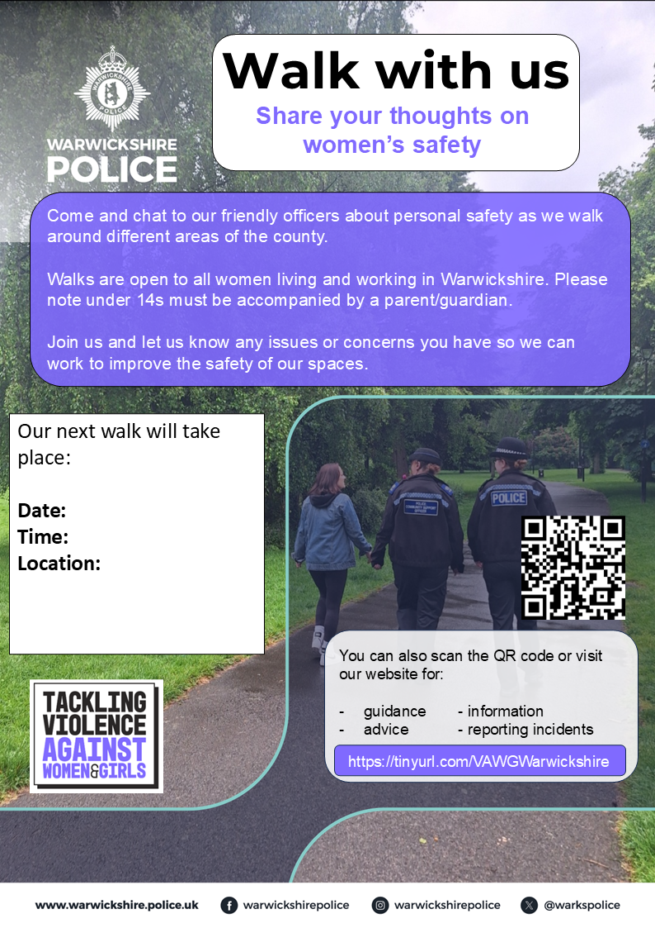
Our Next Walk will take place
Date: Monday 16th November 2026
Time: 6pm
Location: Chase Meadow Community Centre CV34 6BT
The walk will be approx. 2 miles, suitable for all and will end back at the start.

