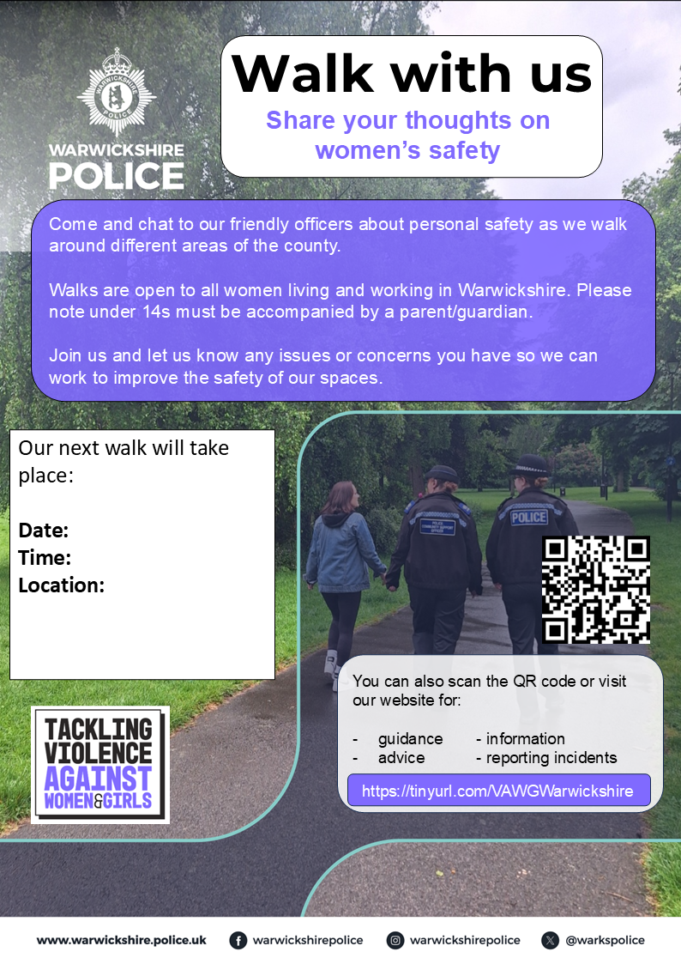
Our Next Walk will take place
Date: Wednesday 20th May
Time: 6:30pm-7:30pm
Location: Meeting outside Pingles Leisure Centre, Avenue Road Nuneaton CV11 4LX
The walk will be approx. 2 miles, suitable for all and will end back at the start.

