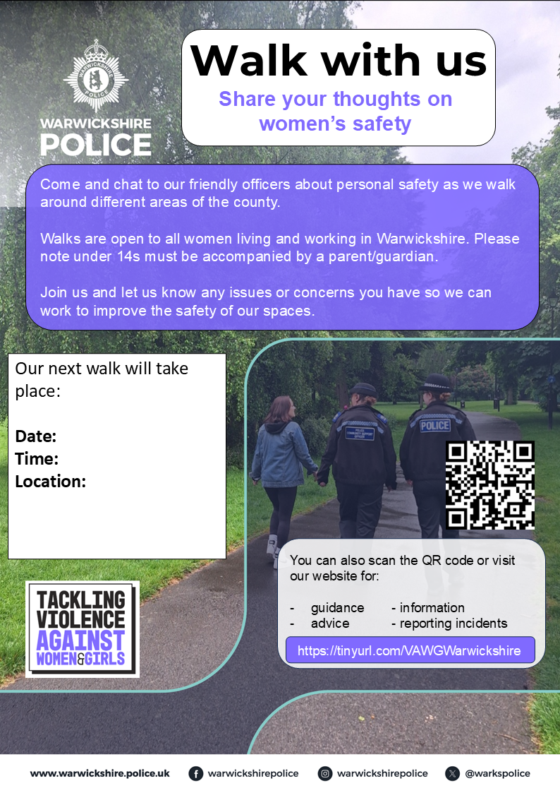
Our Next Walk will take place
Date: Monday 27th of April 2026
Time: 18:00-19:00pm
Location: Hartshill Hayes Country Park, Oldbury road, Hartshill Hayes, Nuneaton, CV10 0TE.

