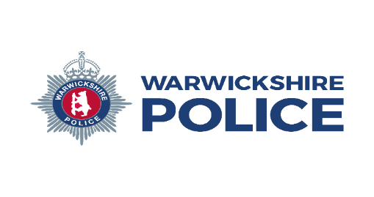


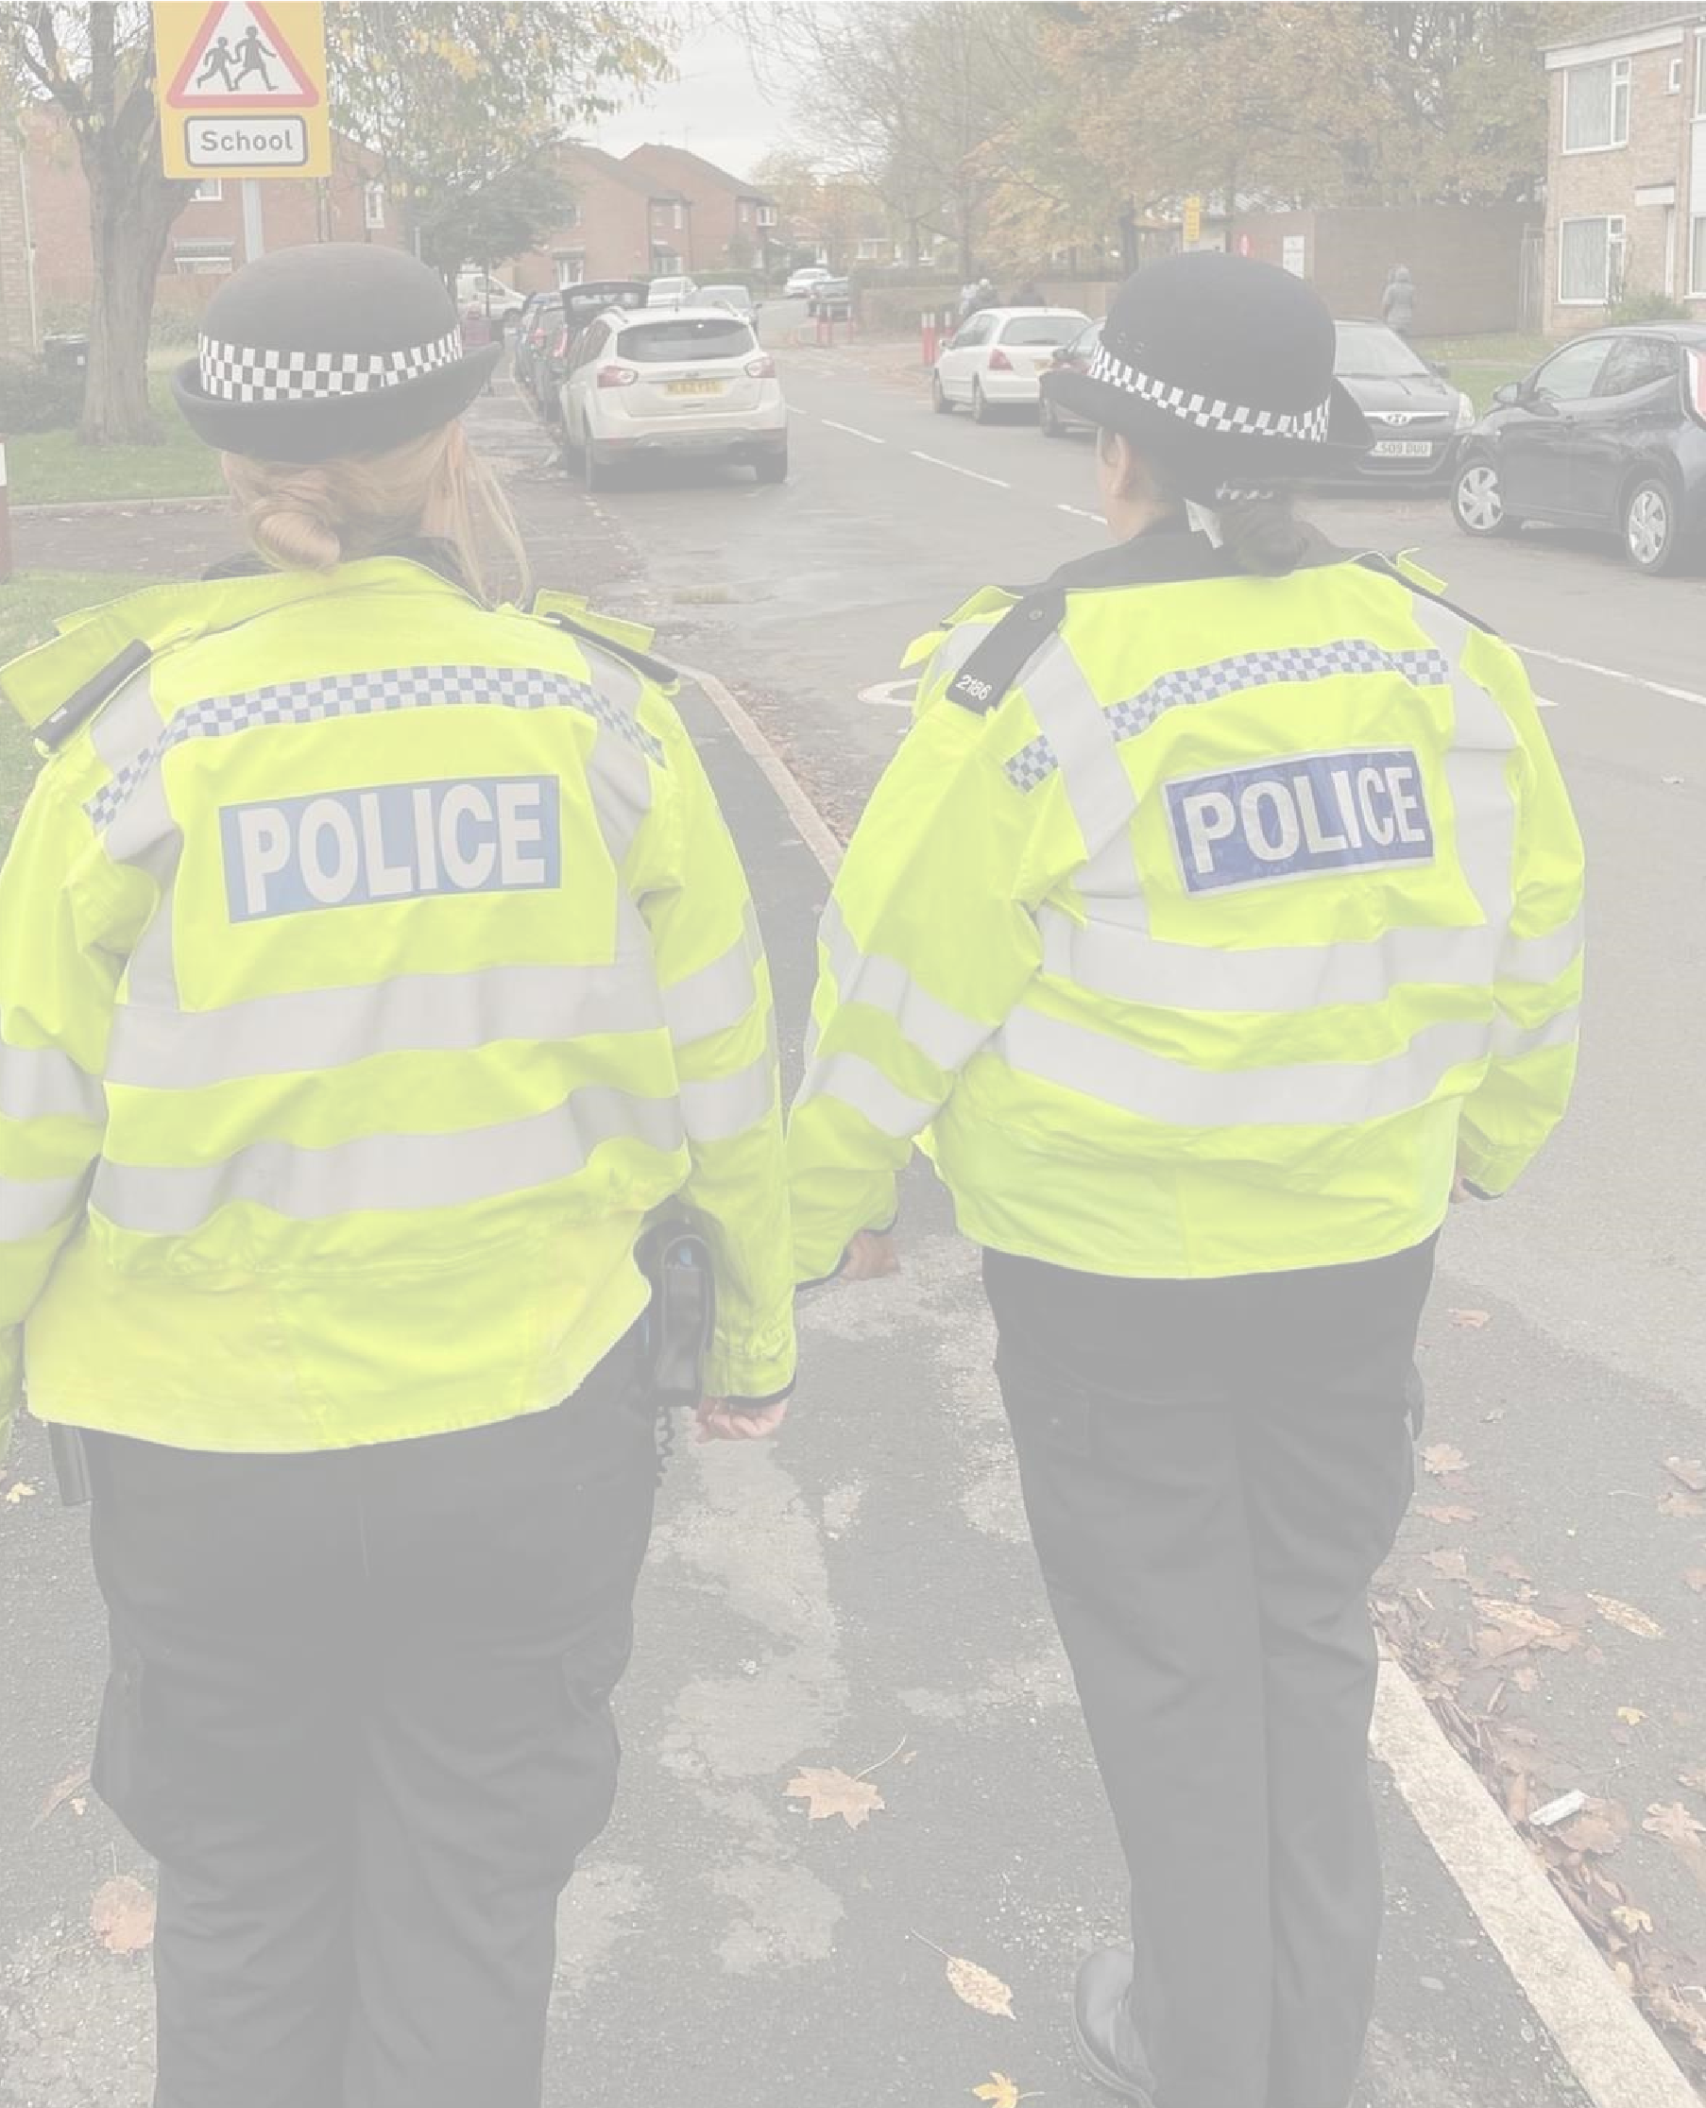
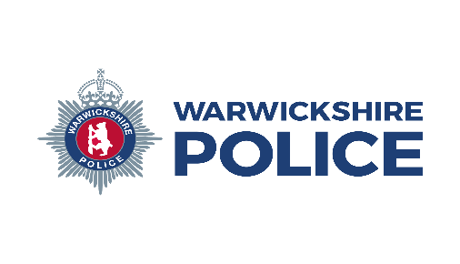

Warwick Safer Neighbourhood Team
Local officers will be at The Gap Community Centre (39 Oakwood Grove CV34 5TD) on 26th October 2026 1100hrs - 1200hrs

Please pop in for a hot drink, enjoy The Gap’s new café area and chat to us about issues or concerns in your local area.

DISCUSS ISSUES IN YOUR

POLICE COMMUNITY
DROP IN

